SIMATS ENGINEERING (SAVEETHA SCHOOL OF ENGINEERING)
Department of Computer Science and Engineering
ASSESSMENT TOOL 3 – Mock Interview

Course Code: | CSA06 |  | Course Title: | Design and Analysis of Algorithms
CO Assessed: | CO5 – Naturalization (BL5, BL6) |  | Assessment: | Assessment Tool 3 – Mock Interview
Weightage: | 30% of CIA |  | Total Marks: | 100
CO5 Statement: | Analyze computational problems using backtracking techniques and complexity classes such as P, NP, NP-Hard, and NP-Complete for combinatorial problem solving.
Student Name: | CH.Akhil |  | Reg. No.: | 192525250
Section / Batch: | 2025 |  | Date: | 31 08 26
Instructions to Students
- Attend the mock interview individually and answer all technical questions clearly.
- Explain the logic, algorithm design steps, and complexity analysis wherever required.
- Demonstrate understanding of backtracking, recursion, and combinatorial problem-solving approaches.
- Differentiate clearly between P, NP, NP-Hard, and NP-Complete problems with suitable examples.
- Maintain clear communication, confidence, and logical presentation throughout the interview.
Question Type |  | Focus Area |  |  | Questions Marks
Mock Interview |  | Demonstrate problem-solving skills in backtracking techniques and complexity classes through technical discussion and algorithmic analysis. |  |  | Q1- Q15 | 100
 |  | GRAND TOTAL: |  |  | 100 Marks

SECTION A – Mock Interview

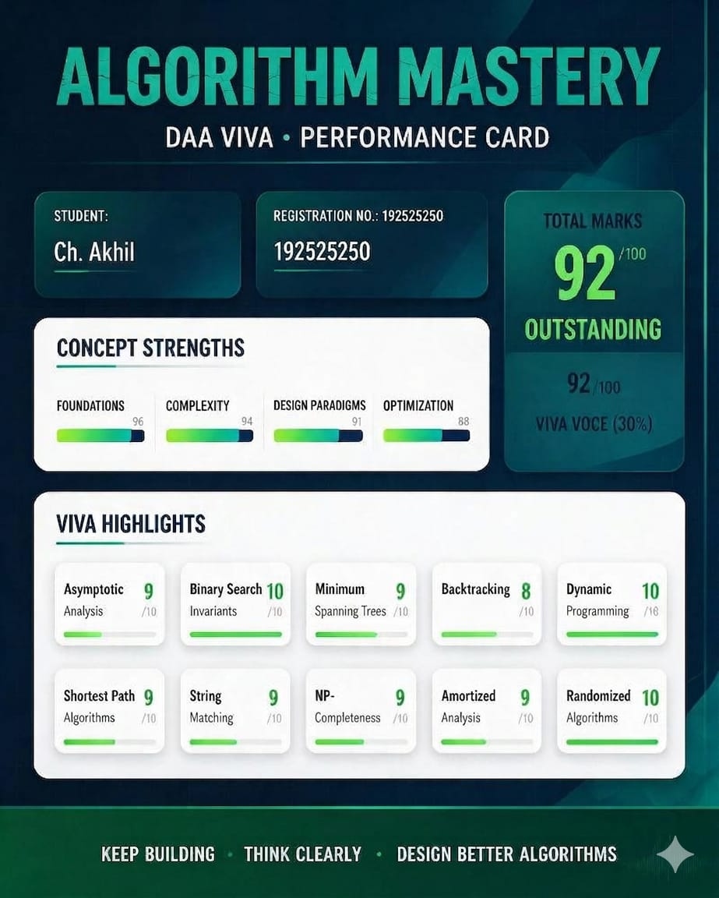

Code of Conduct
I CH.Akhil (192525250) certify that this submission is my original work and that I have adhered to the guidelines specified for this assessment. I understand that any violation of academic integrity rules will result in disciplinary action.
Signature of the Student: Ch.Akhil
Q.N  o. | Technical  Knowledge  (25%) | Problem  Solving  (25%) | Analytical  Thinking  (15%) |  | Communicati on  (15%) | Confi dence  (10%) |  | Response  to  Questions  (10%) | Total Marks (100)
Q1
 |  |  | Overall Total (100)
Faculty In-charge |  |  |  | Course Coordinator |  |  | Head of Department
Signature: _______________ |  |  |  | Signature: _______________ |  |  | Signature: _______________
Date: ___________________ |  |  |  | Date: ___________________ |  |  | Date: ___________________
RUBRICS FOR CALCULATION

Level 4 –  Criteria Wt.  Exemplary |  |  | Level 3 – Proficient | Level 2 –  Developing | Level 1 –  Beginning
Technical Knowledg e | 25% | Demonstrates strong and accurate subject knowledge with in-depth understanding | Shows good knowledge with minor gaps | Basic knowledge with noticeable errors | Lacks fundamental technical knowledge
Problem Solving | 25% | Solves problems logically and applies concepts effectively in real scenarios | Applies concepts with moderate accuracy | Limited problem-solving  ability; requires guidance | Unable to solve or apply concepts
Analytical Thinking | 15% | Analyzes questions critically and provides  well structured, logical  answers | Provides reasonable analysis with some structure | Superficial or partially structured responses | No analytical thinking demonstrated
Communi  cation | 15% | Communicates clearly, confidently, and professionally with proper terminology | Communicates well with minor hesitation | Communication  lacks clarity or confidence | Unable to communicate  effectively
Confiden ce | 10% | Displays high confidence, positive attitude, and professional behavior throughout | Shows good confidence with minor issues | Low confidence; inconsistent behavior | Lacks confidence and professionalism
Respons  e to  Question s | 10% | Responds accurately, promptly, and elaborates with relevant examples | Responds  correctly but with limited depth | Partial responses; needs prompting | Unable to respond appropriately
Marks Evaluation:

